**Experiment – 2.1(b)**

**Student Name: Milan Sharma UID: 23MAI10003**

**Branch: ME – CSE - AIML Section/Group: MAI – 1 (A)**

**Semester: 1st Date of Performance: 04 Oct 2023**

**Subject Name: Python Programming Subject Code: 23 CSH 623**

1. **Aim of the Experiment :**

Write a python program to compare two lists

1. **Objective of the Experiment :**

To compare two lists

1. **Algorithm/ Steps for Experiment**

Python provides multiple ways to compare the two lists. Comparison is the process when the data items of are checked against another data item of list, whether they are the same or not. The methods of comparing two lists are given below.

1.        The cmp() function

2.        The set() function and== operator

3.        The sort() function and== operator

4.        Thecollection.counter() function

**cmp() function**

The Python cmp() function compares the two Python objects and returns the integer values -1, 0, 1 according to the comparison.Note - It doesn't use in Python 3.x version.

**set() function and == operator**

Python set() function manipulate the list into the set without taking care of the order of elements. Besides, we use the equal to operator (==) to compare the data items of the list.

**Code for Experiment :**

list1 = [11, 12, 13, 14, 15]

list2 = [12, 13, 11, 15, 14]

a = set(list1)

b = set(list2)

if a == b:

print("The list1 and list2 are equal")

else:

print("The list1 and list2 are not equal")

**Result/Output :**

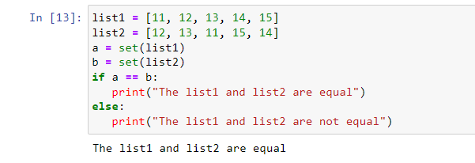

**sort() method with == operator**

Python sort() function is used to sort the lists. The same list's elements are the same index position it means; lists are equal.Note - In the sort() method, we can pass the list items in any order because we are sorting the list before comparison.

**Code for Experiment :**

import collections

list1 = [10, 20, 30, 40, 50, 60]

list2 = [10, 20, 30, 50, 40, 70]

list3 = [50, 10, 30, 20, 60, 40]

list1.sort()

list2.sort()

list3.sort()

if list1 == list2:

print("The list1 and list2 are the same")

else:

print("The list1 and list3 are not the same")

if list1 == list3:

print("The list1 and list2 are not the same")

else:

print("The list1 and list2 are not the same")

**Result/Output :**

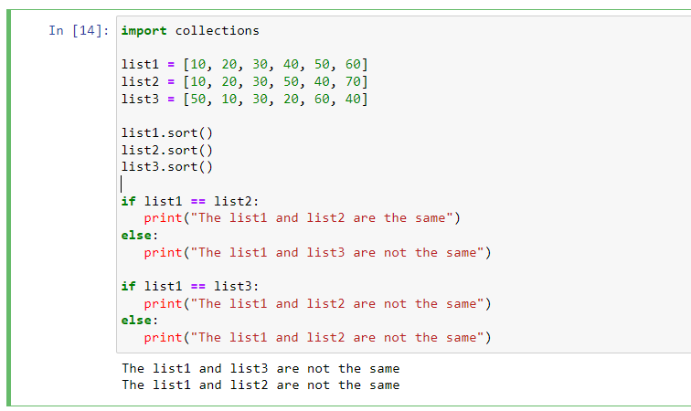

**collection.counter() function**

The collection module provides the counter(), which compare the list efficiently. It stores the data in dictionary format <value>:<frequency> and counts the frequency of the list's items. Note - The order of the list's elements doesn't matter in this function.

**Code for Experiment :**

import collections

list1 = [10, 20, 30, 40, 50, 60]

list2 = [10, 20, 30, 50, 40, 70]

list3 = [50, 10, 30, 20, 60, 40]

if collections.Counter(list1) == collections.Counter(list2):

print("The lists l1 and l2 are the same")

else:

print("The lists l1 and l2 are not the same")

if collections.Counter(list1) == collections.Counter(list3):

print("The lists l1 and l3 are the same")

else:

print("The lists l1 and l3 are not the same")

**Result/Output :**

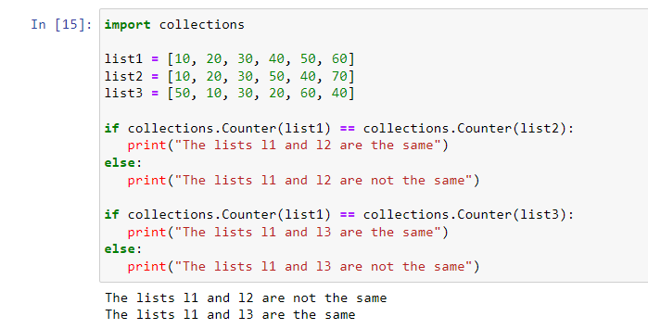

**Learning outcomes (What I have learnt):**

1. Learnt different operations performed on list.
2. Learnt rhe different inbuild function that are performed on list
3. Imported a new library named Collection and know about it.